**Online Certification Course Details:**

**BLOCKCHAIN BASICS:**

**Today I completed 2 lessons:**

### Ethereum Operations

### Incentive Model

**And took quiz on these lessons**

**SNAPSHOTS:**

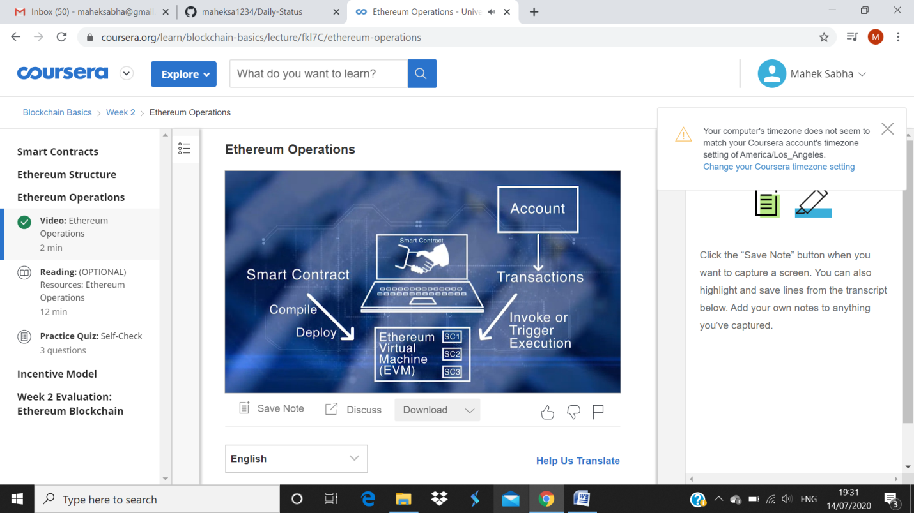

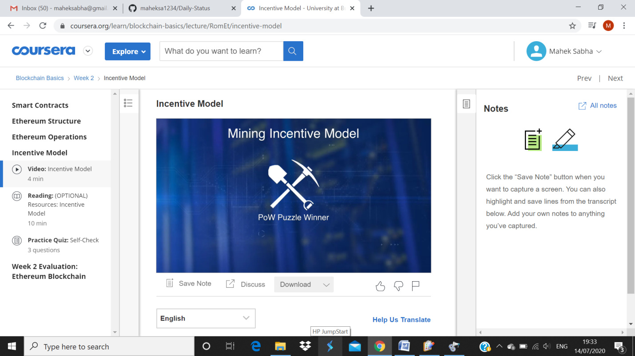

**Test:**

